Corvettes – by Ted Letreille

Come all you boys come into the pub,
I’ll tell you how, we sank the sub,
Before one line, you ever hear,
Set up four quarts of Molson’s beer.

We were only a short way out of Algiers,
The sea was calm, and the sky was clear,
A better setting could ne’er been laid,
For a sub-attack or a bombing raid.

We knew they were waiting down the line,
A plane, a sub, or a floating mine;
My mate remarked as he passed his pack,
Don’t be surprised, if you hear Ack-Ack.

I scarcely had time to light my smoke,
When the Action bell, its warning spoke,
Then over the pipe came the oilers yell,
“Full ahead boys; give her hell.”

If you’ve never been down there it’s hard to know,
Of the crash and roar when the depth charges go
Over the side and off the stern
You feel her list as she makes the turn.

The deck plates bounce, the gauge glasses blow,
Asbestos lugging comes down like snow;
We would like to see what goes on up top,
Where would we be if our steam should drop?

From up on deck, we hear the shout,
“She’s come to the surface” the guns let out,
Over the din the clatter and roar,
Comes the heavy thunder of the B.L.4.

Out on deck, they come on the run,
Trying to reach their forward gun,
With machine gun bullets they sprayed our side,
But again our Gunners opened wide.

“Cease fire; came the Captain’s order,
“They’ve given up; prepare to board her.”
Over the side went the boarding crew,
Each man knew what he had to do.

As they smartly went aboard her,
Not knowing what was in store,
They knew our Gunners wanted
To give her plenty more.

The wounded were lowered into a boat,
Others were placed in a Carley float,
Some dived in to swim to our side,
Many made it; others died.

They were brought to the Sick-Bay,
To be treated by our “Doc”,
None were badly wounded,
But all were suffering from shock.

After a change of clothing,
And a cup of tea,
You’d never have thought,
They had been in the ice-cold sea.

Our boys were still aboard the sub,
They tried their best to keep her above.
Their efforts were futile; it was no use,
Her hull had taken too much abuse.

They waited too long to take their leave,
As the bow took a dive and the stern a heave,
She started down on her last long dive,
They were lucky they all got off alive.

You must admit she’d have been a prize,
To be brought in by a ship our size,
But after all, who are we to say,
We may get a chance some other day.

Let’s drink a toast to Canada’s fleet;
We know it’s small, but hard to beat.
Her men, no doubt, you all have met,
The ones who man our small corvettes.
………………………………………………………………...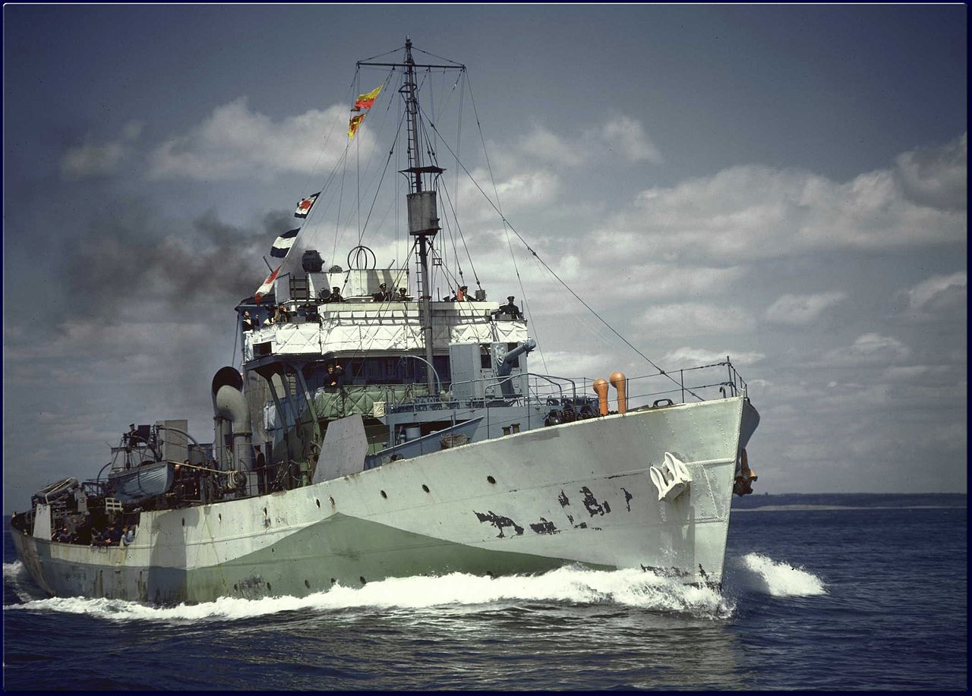
Epilogue: This poem tells the story of HMCS Regina’s sinking of the Italian submarine Avorio off Algiers in the Mediterranean Sea on 08 February 1943. The author, Stoker Ted Latreille, 32, did not survive to get home. He died from complications of an operation for a ruptured appendix onboard Regina, and was buried at sea on 25 March 1943. HMCS Regina didn’t make it home either. She was torpedoed and sunk off Trevose Head, Cornwall 08 August 1944 by U-667, with the loss of 30 of her ship’s company.

Breech-Loading 4-inch Gun

